

**PRESBYTERIAN WOMEN (POJ) Spring 2023**

**SPRING GATHERING**

**First United Presbyterian Church 3401 North Avenue, Richmond, VA**

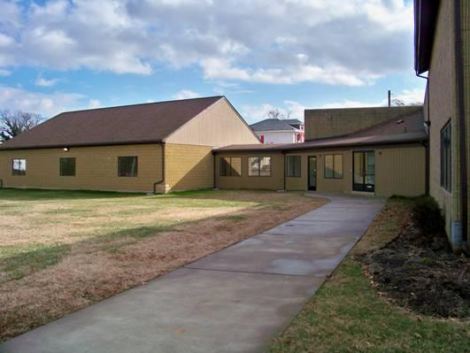

April 29 2023

Registration and Fellowship – 8:30-9:00 Meeting – 9:30-12:30

***SPRING GATHERING***

***First United Presbyterian Church***

***3401 North Avenue***

***Richmond, Virginia 23222***

***April 29, 2023***

**Registration**

Join Presbyterian Women from across the Presbytery of The James for the annual Spring Gathering on Saturday, April 29, 2023 in person at First United Presbyterian Church or on the virtual platform, Zoom.  Check in will begin at 9:15 a.m., and the Gathering will convene at 9:30 a.m.

We are meeting in person this year; your Presbytery’s Coordinating Team is aiming to make the day worth your presence. But if not, we are also going to have virtual access on Zoom. The Gathering will include mission speakers, the annual business meeting, the installation of the new PW-POJ leadership team, the “In Memoriam” necrology, and communion.

To register, send email to [kathypeebles@verizon.net](mailto:kathypeebles@verizon.net) . Note your name, Church and if in person or virtual. If virtual you will then get the Zoom link. This will allow us to have a more accurate number of who will be on Zoom as well as in person.

Our speakers will include: Rev. Mary Newburn-Williams, Pastor First United Presbyterian Church, Clayton Rascoe - Massanetta Springs Conference Center , and a representative from Lois Ann's Hope House.



Message from your Moderator

This year we are Hybrid!! Have a virtual option but will also be in person At First United Presbyterian in Richmond!

We will have Clayton Rascoe from Massanetta Springs to share with us the **wonderful** plans for Massanetta. Also, Cait Woodward, Interim Director of Loisann’s Hope House to Share more about our Spring Gathering Mission choice

The recipient of our offering at Spring Gathering 2023 is Loisann’s Hope House. Thank you for your support of this effort. Please forward your donations to Sally Beale, Treasurer of PWJ, 900 Lunenburg Avenue, Blackstone, VA 23824. Note in memo for Spring Gathering Loisann’s Hope House.

Have you all enjoyed this year’s Horizon bible study, Celebrating the Sabbath? Has it made you stop and reflect on How you celebrate Sabbath as I have?

Next year’s Study title is ***Sacred Encounters: The Power and Presence of Jesus Christ in Luke-Acts* by Olive Mahabir**. Learn more about this study by attending the Synod Summer Gathering this June. The Summer Gathering has gone virtual. Join us June 9-11, 2022 At Massanetta Springs. A virtual Option is in the works. But come and be in persona, interact with your sisters in faith. Great workshops planned. Your Moderator was convinced to do one, A quilter’s workshop on Friday the 9th.

I want to thank those who have agreed to serve on the Coordinating team with us next year. This is a wonderful group of ladies who care about all of you and your congregations. If asked, please consider being a part of this team of amazing women to continue the mission of the Presbyterian Women USA.

Yours in Prayer and service,

Kathy Peebles

Moderator

Peace and Justice Coordinator Report

The recipient of our offering at Spring Gathering 2023 will be Loisann’s Hope House.

Loisann’s Hope House is the Fredericksburg region’s oldest and largest family homeless shelter. They give hope to help sustain during difficult times. Their mission is to break the cycle of homelessness one family at a time with a vision no family homeless. In the past year, they served 447 clients and answered 9,000 calls.

To learn more about Loisann’s Hope House please visit their website at https://loisannshopehouse.org

I welcome suggestions anytime for offering considerations. You may email me at [twintoni@aol.com](mailto:twintoni@aol.com), write me: 14903 Lansgate Ct., Midlothian, VA 23112 or call me at 804.639-9511.

Antoinette Archer

Peace and Justice Coordinator

PRESBYTERIAN WOMEN’S FALL Sisterhood Social

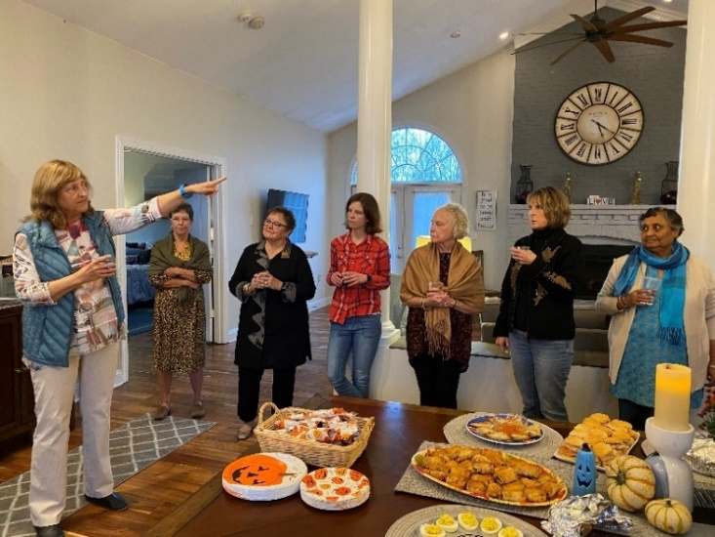Twenty-one ladies attended the Culpeper Presbyterian Women’s Circles’ Fall Sisterhood Social, held on Friday, October 28th, at Barbara Fleming’s “Peacefield”, in Boston, VA. After we opened with a prayer, Barbara was invited to provide a description of this delightful venue, which she runs as an AirBnB. The expansive open plan design made this the perfect setting for our social event. Guests had been invited to bring finger foods to share, while beverages were provided. Guests mingled and chatted, in groups large and small, and a great time was had by all present!

We look forward to our next Sisterhood Social, next year!

# Fall Fundraiser – “Munchin’ FOR Missions – *and More!”*

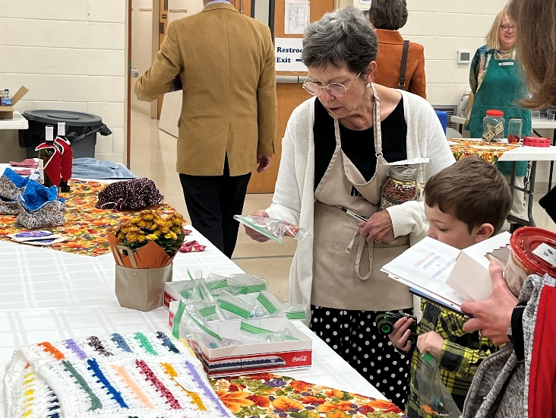Culpeper Presbyterian Women’s Circles’ annual fundraiser, “Munching for Missions – *and More!*” was held on Sunday, November 13th and was a big success! This followed the format of the last couple of years, as a walk-through bake sale, and offered craft items as well as baked goods – hence the “*and More!*” Donna Chabot was the lucky winner of the M&Ms jar, with her very close estimate of the number of M&Ms in the jar, while Dorothy Jones’ ticket was selected as the recipient of the 50/50 raffle proceeds!   
Congratulations to you both!

To date we have tallied proceeds of $3,170 with more anticipated to come! At the next meeting of our PW Coordinating Team, we will create a list of some potential missions - Local, National and International - who might benefit from our funds. After our January 12th, 2023 Morning Circle, during the business meeting, members will be asked to vote to approve this list of recipients.

**PW OF SECOND PRESBYTERIAN – PETERSBURG**

**CELEBRATE 60TH ANNIVERSARY**

**OF LENTEN SERIES**

This year will mark the 60th anniversary of the Lenten Series at Second Church, Petersburg. The event began as an outreach ministry to the community during Lent. Our neighborhood then had several thriving factories, and these brief services and luncheons were a means of providing spiritual refreshment as well as fellowship for the

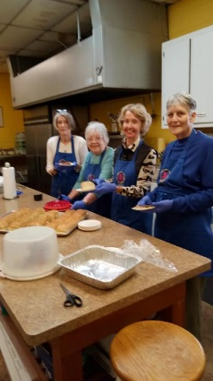office workers during their lunch hour.

Today, our neighborhood has a different character, but the Lenten Series continues to provide an important contact to the

Petersburg community during this Holy season. Ministers from the various denominations in the area are invited to preach, and our PW continues to serve delicious lunches. Happily, several years ago, the Men’s Group joined us serving the coffee and tea and helping with the clean-up chores. What a wonderful help that was!

Proceeds from these luncheons go to help with the many mission projects the PW has, so we hope to continue this Lenten Series for years to come.



**First United Presbyterian Church**

The Women at First United joined with the Men to surprise two Homes that they have adopted with Christmas dinners, the dinners were catered.

The women supplied socks, gloves, toiletries, and snacks. We usually help with the cookout in July but, of course we could not last year. We are doing Bible Study by teleconference. Covid 19 has encourage the ladies to pray, seeking God for peace and more love in this world. Like other congregations we pray for the day when we will be able to worship in the building.

**Submitted by**

**Evalyn Page**



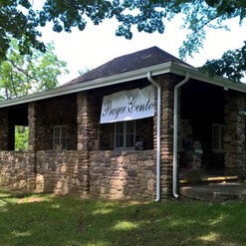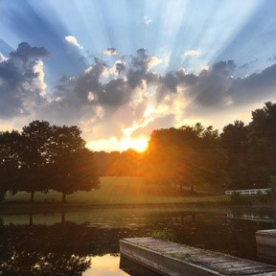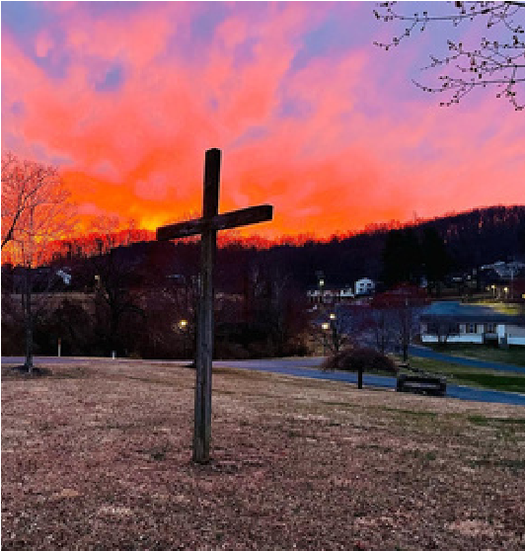

**PRESBYTERIAN WOMEN**

in the Synod of the Mid-Atlantic

2023

Summer Gathering

June 8-11, 2023

Open your heart to a Sacred Encounter . . .

Come unto me (Luke 18:16)

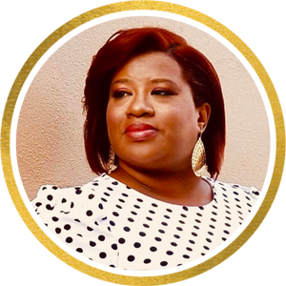

Rev. Dr. Olive Mahabir

Shani McIlwain

**Featuring...**

Author - Podcaster - Leadership Coach Sharing Love, Light and Life www.shanimcilwain.com

Author of 2023-2024 Horizons Bible Study Sacred Encounters: The Power and Presence of Jesus Christ in Luke and Acts



Massanetta Springs Camp and Conference Center

Harrisonburg, Virginia 22801

www.massanettasprings.org

Join us at

**For more information**

**and to register:**

**www.pwsma.com**

**Also joining us are:**

**PW Moderator Kathy Reeves**

**& PW Executive Director Susan Jackson Dowd**

**Hybrid Option**

**Plenaries & some**

**workshops**

**will be**

**available on zoom.**



**All the latest from PW Churchwide!**

*PW NewsBytes—*formerly the *PW Quarterly Mailing*—brims with “news you can use” from Presbyterian Women Churchwide! Just like the name suggests,*PW NewsBytes*is fully digital, which is good stewardship (of both finances and trees) and makes for easy sharing and a more connected PW community.

The March 2023 edition includes news you'll want to know and share about PW events, resources, opportunities and much more! (And PW newsletter editors or creators, you're welcome—encouraged, even! — to include any of these items in your newsletter.

Learn about

* PW's participation in the Commission on the Status of Women in New York,
* special offers (Buy One, Get One Free and sale pricing) on *Horizons* magazine and Bible study editions,
* ways to offer financial support to PW Churchwide, including gifts to the Annual Fund,
* online discussions of five books (and one film) with PW's Justice and Peace committee in 2023,
* and more!

[**Enjoy (and share) *PW NewsBytes*!**](https://presbyterianwomeninthepcusainc.cmail20.com/t/t-l-fhkhdlk-drvlikdk-r/) Presbyterian Women’s Annual Fund (the Mission Pledge) makes possible every mission, program and resource of PW. Give now to support Presbyterian Women’s witness in the world.

[**GIVE TO PW's ANNUAL FUND**](https://presbyterianwomeninthepcusainc.cmail20.com/t/t-l-fhkhdlk-drvlikdk-y/)